CONNECTED, LEVEL 2 2015, Have You Checked?  Why Do Our Muscles Get Tired?  by Zoe Armstrong and Dave Armstrong  Overview  This article focuses on the concept of muscle fatigue. As they read, students also learn about how to carry out a scientific investigation and think about how to design one in a way that improves the reliability of the results.  A Google Slides version of this article is available at www.connected.tki.org.nz. This text also has additional digital content, which is available online at www.connected.tki.org.nz. |  |  | 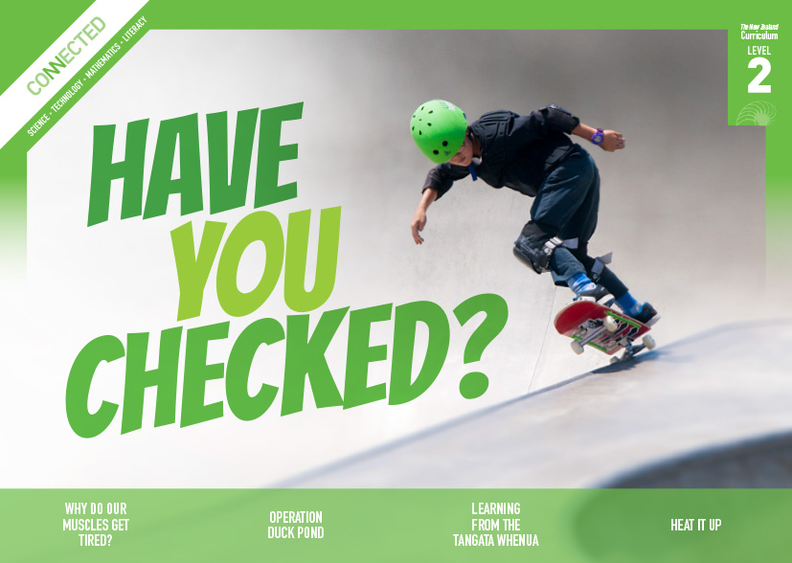  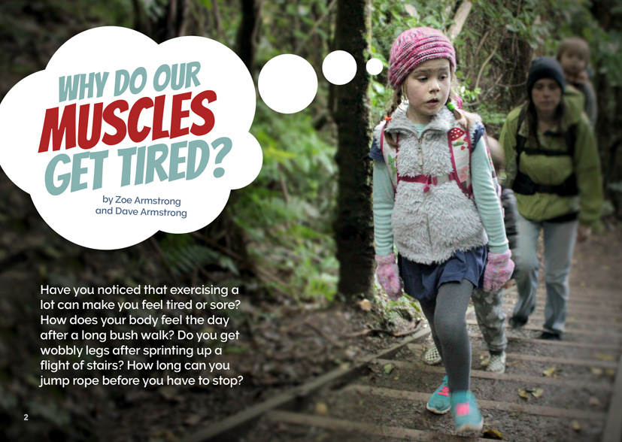
Science capability: Critique evidence |  | Text characteristics

Science knowledge is based on data derived from direct or indirect observations of the natural physical world. An inference is a conclusion drawn from those observations; it is the meaning you make from the observations. Understanding the difference between an observation and an inference is an important step towards being scientifically literate.  Being ready, willing, and able to critique evidence is also an important step towards being scientifically literate. Students must be able to assess the quality and reliability of both the observations (data) and the inferences made from those observations. In order to know what sorts of questions to ask to evaluate the trustworthiness of data, students need both methodological knowledge (how data is generated and collected) and statistical knowledge (how data is collated and analysed).  For more information about the “Critique evidence” science capability, go to http://scienceonline.tki.org.nz/Introducing-five-science-capabilities/Critique-evidence |  | - A conversational tone that includes direct questions to the reader.  - Photographs, diagrams, illustrations, and subheadings to support the text.  - A description of a scientific investigation that provides a model to follow.

Curriculum context

SCIENCE
NATURE OF SCIENCE: Investigating in science  Achievement objective  L2: Students will extend their experiences and personal explanations of the natural world through exploration, play, asking questions, and discussing simple models. |  | NATURE OF SCIENCE: Understanding about science  Achievement objective  L2: Students will appreciate that scientists ask questions about our world that lead to investigations and that open-mindedness is important because there may be more than one explanation.  LIVING WORLD: Life processes  Achievement objective  L2: Students will recognise that all living things have certain requirements so they can stay alive. |  | Key Nature of Science ideas  Scientists:  - evaluate the trustworthiness of data by asking questions about investigations carried out by others  - undertake more than one trial to provide sufficient evidence to support a theory  - replicate investigations to critique the evidence or data provided by other scientists  - check that there are enough samples to reliably establish a conclusion or theory  - look carefully at the way data has been collected when they consider investigations done by others.  Key science ideas  - Oxygen and food molecules are transported by the blood to all the cells of our body, including our muscle cells  - Oxygen and food molecules are used in our cells to make energy  - All living things have structural, physiological, and behavioural features that help them to survive.

ENGLISH

READING  Ideas  Students will show some understanding of ideas within, across, and beyond texts. |  | INDICATORS  - Uses their personal experience and world and literacy knowledge to make meaning from texts.  - Makes meaning of increasingly complex texts by identifying main ideas.  - Makes and supports inferences from texts with some independence. |  |  |  | THE LITERACY LEARNING PROGRESSIONS  The literacy knowledge and skills that students need to draw on by the end of year 4 are described in The Literacy Learning Progressions.

MATHEMATICS AND STATISTICS
STATISTICS: Statistical investigation  Achievement objective(s)  L2: Students will conduct investigations using the statistical enquiry cycle:  - posing and answering questions  - gathering, sorting, and displaying category and whole-number data  - communicating findings based on the data. |  |  |  | Key statistical ideas  - Data can be used for different purposes.  - Data can be used to predict a future event.  - Organising data and looking for patterns and trends can reveal useful information.

Critiquing evidence

The science capability “Critique evidence” is about students evaluating the quality of the data supporting a scientific claim or idea (http://scienceonline.tki.org.nz/Introducing-five-science-capabilities/Critique-evidence).
Scientists use empirical evidence to develop theories about how the world works.
- Empirical evidence is data gathered from observations, experiments, and investigations.
- Scientific claims are only as dependable as the evidence on which they are based.
- Scientists design their investigations carefully to ensure that the data they gather is both reliable and valid. Valid data is data that measures what it is supposed to measure – it answers the research question. Reliable data is dependable and consistent. Replicating the experiment and getting the same results makes us more confident the data is reliable.
- To gather high-quality evidence that is reliable and valid, scientists measure accurately, keep conditions the same or control variables that might influence measurements or observations, repeat tests or investigations many times, investigate multiple examples, and/or use statistical sampling techniques to make their observations or data as representative and accurate as they can.
Students should be critiquing and evaluating the quality of data gathered from their own investigations by:
- engaging in a range of investigation types, exploring, comparing, classifying, identifying, seeking patterns, using models, making things to test ideas, and investigating systems so that they learn different ways to gather different types of data
- identifying ways to make the data they collect in their own investigations as accurate and reliable as possible
- suggesting and developing ways to control conditions or variables or keep things fair, repeating observations or measurements or tests and developing appropriate sampling methods
- applying their developing understanding of statistics and probability when making decisions about sample size and repetitions and when working with their data.
Students should also be encouraged to look for, consider, and critique methods and data underpinning scientific claims made by others. This includes critically examining the appropriateness of methods and the quality of evidence used to develop scientific claims in the media and other sources.
Teachers can:
- help students to be more critical consumers of science information by being explicitly critical themselves
- support students to identify correlations as evidence of a potential relationship, but not necessarily cause and effect
- ask questions such as:
  - Would this always happen?
  - How sure are you of your measurements?
  - How many times should you repeat these tests/measurements?
  - Is this a fair result?
  - What may have influenced the data?
  - Was there a big enough sample?
  - Does the data match the claim?
  - How much variation is there in your results? Why might that be?
- support students to evaluate how data is presented; for example, if data is presented graphically, is this done appropriately or is it misleading? (This draws on another science capability, Interpret representations.)
- support students to apply their understanding of statistics and probability when considering claims, evidence, and data.
- establish a science classroom culture by:
  - modelling and encouraging a critical stance
  - encouraging students to consider the quality and interpretation of data underpinning scientific claims
  - using media headlines to introduce learning conversations and demonstrate the relevance of critiquing evidence to everyday life.
A range of questions and activities designed to get students to critique evidence is available on the Science Online website: http://scienceonline.tki.org.nz/Introducing-five-science-capabilities/Critique-evidence

Meeting the literacy challenges

The literacy demands of this text lie in the interpretation of the science ideas and concepts related to how muscles work and tire. The focus of each paragraph is clearly indicated by heading statements or questions. Sequence markers such as: “If we use…”, “This means….”, and “When….” help the reader to build understanding. Questions directed to the reader provide clear guidance.
The following strategies will support students to understand, respond to, and think critically about the information and ideas in the text. You may wish to use shared or guided reading, or a mixture of both approaches, depending on the reading expertise of your students and the background knowledge they bring to the text.
After reading the text, support students to explore the activities outlined in the following pages.

TEACHER resources

Want to know more about instructional strategies? Go to:
- http://literacyonline.tki.org.nz/Literacy-Online/Teacher-needs/Reviewed-resources/Reading/Comprehension/ELP-Years-1-4
- “Engaging Learners with Texts” (Chapter 5) from Effective Literacy Practice in Years 1 to 4 (Ministry of Education, 2003).
Want to know more about what literacy skills and knowledge your students need? Go to:
- http://literacyonline.tki.org.nz/Literacy-Online/Student-needs/National-Standards-Reading-and-Writing
- http://www.literacyprogressions.tki.org.nz/
“Working with Comprehension Strategies” (Chapter 5) from Teaching Reading Comprehension (Davis, 2007) gives comprehensive guidance for explicit strategy instruction in years 4–8.
Teaching Reading Comprehension Strategies: A Practical Classroom Guide (Cameron, 2009) provides information, resources, and tools for comprehension strategy instruction.

INSTRUCTIONAL STRATEGIES

FINDING THE MAIN IDEAS
DISCUSS the title and introduce the text, providing a brief overview. Tell the students that the text contains explanations and facts about how our muscles work. Point out that some information is provided in bulleted lists (page 5) and bulleted questions (page 7) to make it easier for the reader to find and understand that information. Also direct them to the chart on page 6. Explain to them that it contains information about an experiment that isn’t included in the text above.
Read page 2. Help the students to make connections to their prior knowledge by having them think, pair, and share their thoughts about exercise and tiredness.
- What sorts of activities make you feel tired?
- How do your muscles feel after exercise?
- What do you think is happening?
Construct a KWL chart with the students. Prior to reading, have the students use the chart to IDENTIFY what they know and what they want to know. As they read, encourage them to REVIEW the questions in column 2, checking off any questions that they can now answer and adding any new questions. After the reading, have them review column 1 so they can identify any misconceptions they may have held prior to reading the article.
What we think we know | What we want to know | What we have learned
Explore the heading Investigating Fatigue on page 5. DISCUSS what is involved in a scientific investigation. Have the students share what they know and add this information to their KWL chart, along with any more questions that have emerged.
- Have you ever taken part in an investigation?
- What do people do when they conduct an investigation?
- How might people investigate something in science?
- How might people investigate muscle fatigue?
As they read, support the students to IDENTIFY the steps that Moana and Oscar took to undertake their investigation.
Have the students respond to the questions on page 7. DISCUSS their responses and the reasons for their responses. EXPLAIN that when they do this, they are acting like scientists. They are drawing inferences from Moana and Oscar's observations, which is also an important reading strategy. Scientists look for clues in evidence. Writers do not always tell us all the information directly, but we can infer some of the meaning from clues in the text.
- What can you infer about Oscar and Moana from the information in the text? How well do they get on? How do they work things out between them?
- What clues did Moana and Oscar’s data provide about who had the fittest fingers?
After reading page 8, EXPLAIN that when we draw inferences, we need to think about whether they are sensible or not. This is called “critiquing evidence”. REVIEW the steps that Moana and Oscar undertook in their investigation. At each step, encourage the students to share the questions they would ask Moana and Oscar and the suggestions they would make to ensure that Moana and Oscar got reliable evidence.
REVIEW the KWL chart to identify what the students have learned about muscle fatigue. Ask them to review their original ideas and to think about how these may have changed. Have them create a simple concept map to show what happens to muscles during exercise and what people can do to prevent muscle fatigue. Write the words “muscle fatigue” in the centre and have them use one colour to record “Causes” in bubbles on one side of the map and another colour to record ways of “Beating fatigue” on the other. Have the students write simple statements to describe the relationships that the concept map illustrates (for example, “Food provides the body with … to beat fatigue.” “Oxygen provides the body with…”.)
Ways to beat muscle fatigue
muscle fatigue

Causes of muscle fatigue

Check the students' understanding by presenting them with scenarios, for example:
- Paora went for a 5 kilometre run with his cousin Jamie. Paora ate a banana before he went, but Jamie had nothing. What do you think happened and why?

USING THE DIAGRAMS TO CLARIFY THE TEXT
Have the students read the text on page 4 and look closely at the diagram. EXPLAIN that the author has included the diagram to show how we use oxygen to make our muscles work. Point out the key that shows how oxygen and blood move through the body. Have the students work in pairs to create a simple flow diagram that illustrates how our muscles work and what happens when we exercise hard. Have each pair work with another pair to critique their diagrams, checking that they accurately represent these processes.
Using the digital version of the text (available at www.connected.tki.org.nz), have the students watch the animation showing how oxygen is sent from the lungs to muscles around the body (slides 11–16). Ask them to compare their flow diagrams with the animation and discuss any changes they could make to their diagrams with this additional information.
DISCUSS the data table on page 6. Introduce the term “data table” if the students do not already know it. Point out the way the data is organised into rows and columns with subheadings, and demonstrate how it could be converted into a graph with an x- and a y-axis.
- Which heading represents the x-axis? Which represents the y-axis?
- What patterns do you notice in the data?
- Which do you think is easier to read … a table or a graph?
- If you were to graph this data, would it be better to use a line graph or bar graph? Why do you think that?

DEALING WITH UNFAMILAR VOCABULARY
During the reading of the text, have the students locate specific words that are unfamiliar to them and make sure that the meanings are clear. Create a class word wall showing new vocabulary from the text and its meaning.

Key science ideas
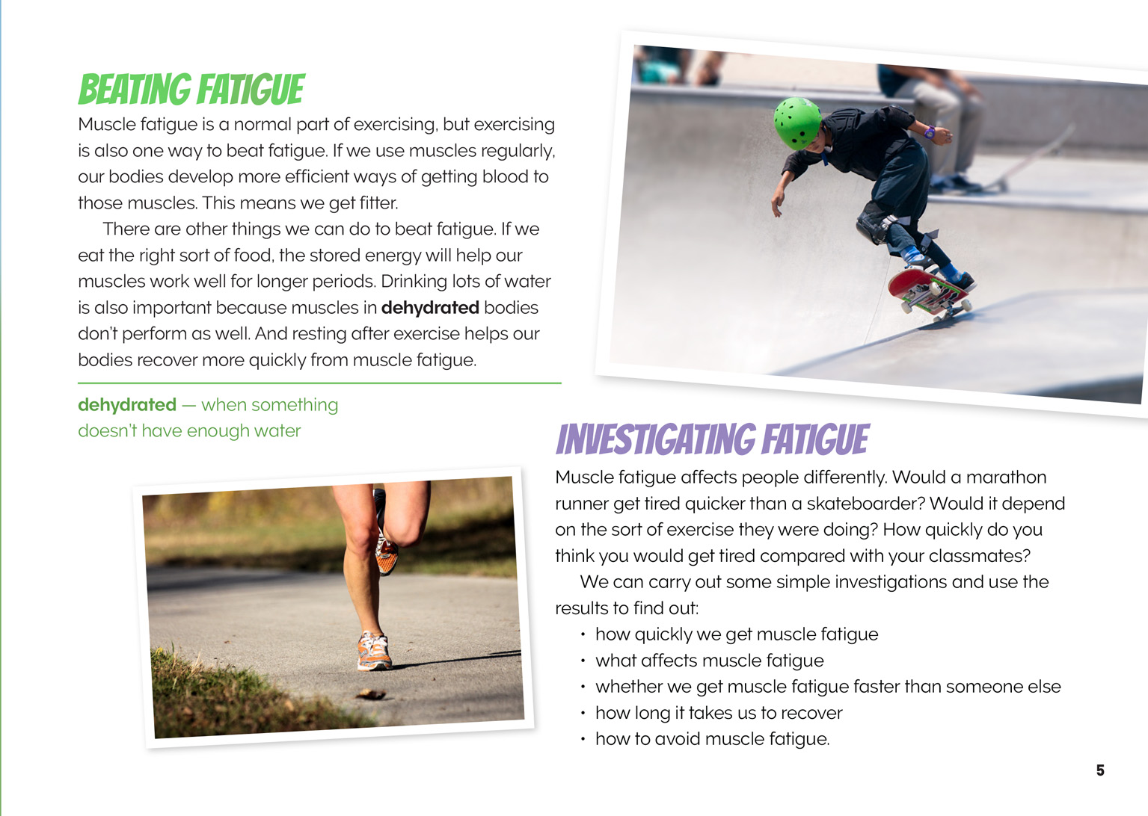 | Scientists design their investigations to make sure the data they collect is reliable.  Scientists ask questions that lead to investigations.  All living things have physiological features that help them to survive.
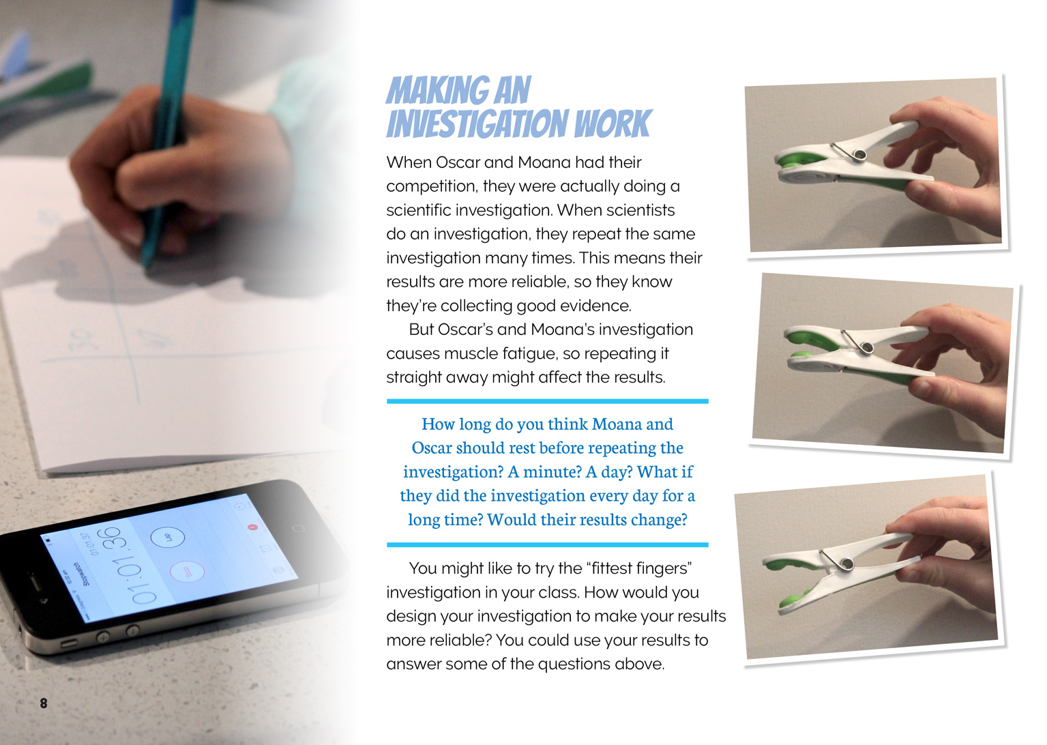 |  | Scientists ask questions to evaluate the trustworthiness of data.  Scientists carry out more than one trial to provide sufficient evidence to support a theory.  By repeating the experiment scientists are more confident the data is reliable.

Learning activities
The following activities and suggestions are designed as a guide for supporting students to explore and develop understandings about the science capability “Critique evidence”. Some activities focus directly on the science capability. Other activities extend student content knowledge across the learning areas. You are encouraged to adapt these activities to support your students’ learning needs.

exploring the science

Activity 1: Investigating fatigue
Initial exploration
Begin this extended activity by working with the students to conduct an investigation based on one of the following suggested activities:
The “Finger Marathon” activity on the Science Learning Hub is an extended version of the investigation Moana and Oscar carried out. (http://sciencelearn.org.nz/Contexts/Sporting-Edge/Teaching-and-Learning-Approaches/Finger-marathon)
The “Muscle Fatigue Labs” offer a variety of activities that students could carry out with considerable independence. They include opportunities to explore the relationship between glycogen (muscle sugar) and lactic acid and to compare cardiac and skeletal muscles. (www.myscience8.com/human_biology/module_3/muscle_fatigue_labs_form.pdf)
“No Pain No Gain” provides activities to explore the impact of muscle fatigue on reaction time and fine motor skills. (http://www.utmb.edu/tstem/nsbri/no_pain_no_gain.pdf)
The “Muscle Fatigue” activity provides ideas for exploring the impact of different kinds of stress (repetitive contractions or sustained contractions) on small and large muscles. The students could use those approaches or design their own investigations wthin a New Zealand context. (http://www.ebsinstitute.com/Baseball/EBS.crb3sa.html)
Discuss the process of the investigation the students undertook and prompt them to critique the quality of their conclusions.
Was this a fair test?
How reliable was the evidence you gathered?
How confident are you of your results?
Student-designed investigations
Have the students design their own investigations. These could be based on the suggestions on page 5 of the article or the students’ own questions. Some alternatives include:
Do large muscles in our legs tire as quickly as smaller muscles in our fingers?
Do our muscles tire more quickly when we are tired at the end of the day than when we are fresh in the morning?
Do large muscles become fatigued more quickly than small muscles?
Which muscle groups tire first?
Which activities induce higher heart rates? (You would need to teach them how to take their pulse. See www.wikihow.com/Check-Your-Pulse or read “Don’t Sit If You Want to Keep Fit” from Connected 4, 2015, p. 27.)
Ask questions to help the students design their investigations, for example:
How many times will you need to repeat this?
What parts of the investigation do you need to keep the same each time? Why?
What are some factors that might affect your results?
The students should make predictions before they begin their investigations and then compare their results with their predictions.
Were the results what you expected?
How might you explain any differences?
Have the students share and compare their results.
What patterns do you notice?
Are there differences in the results different groups got for the same test? How might you explain those differences?

Activity 2: Fighting fit
Reread page 5 and focus on the concept that exercise can cause fatigue but regular exercise helps beat fatigue. Read the text box on page 9 about how Barrett Hocking beats fatigue. Have the students list all the suggestions in the article about how to fight fatigue (nutrition, rest, water, practice). Talk about how this knowledge can be used to get fit and improve health and well-being.
Explain to the students that this will be an extended investigation over several weeks that will be part of their learning in mathematics, English, and health and physical education, as well as in science. Their task will be to use what they know to construct a personal fitness programme that they will carry out during physical education time.
Give the learning a sense of purpose by connecting it to an actual event, for example, the need to prepare for the winter sports season or to be in good condition for a school performance. Help each student set themselves personal goals for improving their fitness. You could connect this learning to the suggestions in the Curriculum in Action book Enjoying Movement (Ministry of Education, 2001) and in particular to the learning experience it describes for “Setting Fitness Goals” (http://health.tki.org.nz/Key-collections/Curriculum-in-action/Enjoying-movement/Possible-learning-experiences/Setting-fitness-goals).
Consider inviting people from the community to share how they keep fit and fight fatigue. Invite the students to suggest possibilities and be creative (for example, you might invite an athlete, a personal trainer, a dancer, or someone training for a waka ama competition).
Organise the students into small groups for this investigation. Consider this carefully. You may wish, for example, to set up groups that combine people of different levels of fitness or with a shared interest or goal.
Encourage the students to take a scientific approach to setting their goals, measuring their progress, and identifying ways of exercising and caring for their bodies that are effective. Have them use graphs to put the emphasis on the rate of individual progress rather than a comparison between individuals. The students might select one of the tests for muscle fatigue and repeat it at the same time each week.
Make explicit to the students that they need to critique their process and the evidence they collect to ensure that the inferences they draw from their observations are as reliable as possible. For that reason, each group is to write up a design brief for their investigation and present it to the whole class before they begin. Prior to these presentations, remind the class of the important questions they need to ask to ensure that the evidence they collect and the inferences they draw make sense. After the groups have made their presentations, it is important that students are given the opportunity to revise their plans and then present them again for further critique.
Allow several weeks for the investigations to proceed, with opportunities for the groups to review the data they are collecting and how effective they think their approach to fitness is proving. Keep prompting them to review the quality of their data and whether it is really giving them the information they need.
When the investigations have been completed, the students share what they have learned with the class. Prompt the students to critique the evidence and identify further questions that arise from each investigation. Give them time to reflect on the learning in small groups and to make a personal record in their science journals:
What have you learned from this experience?
Is there anything that you learned from your own investigation or from other people's investigations that you would like to make part of your regular routine?
How could you make that change?
Extension
Discuss the fact that the purpose of science is to generate knowledge that is used to understand our world. Ask the students if there is anything that they have learned that they would like to share with others. If so, ask:
Who would you like to share this information with? (audience)
What is it you would like to tell them? (purpose)
What is the best way to reach this audience? (medium and genre)
What are some strategies you can use to appeal to your audience?
Encourage the students to be creative. For example, they might create a video or PowerPoint presentation in which they encourage their peers and whānau to try these tested methods of meeting their fitness goals.

RESOURCE LINKS

“Experiment: Muscle Contraction and Fatigue” from Backyard Brains. https://backyardbrains.com/experiments/fatigue
“How to Check Your Pulse” from WikiHow. www.wikihow.com/Check-Your-Pulse
“Muscle Fatigue” from Event-Based Science. www.ebsinstitute.com/Baseball/EBS.crb3sa.html
“Muscle Fatigue Labs” from Science 8 on the Web. www.myscience8.com/human_biology/module_3/muscle_fatigue_labs_form.pdf
“No Pain No Gain” from the University of Texas Medical Branch. www.utmb.edu/tstem/nsbri/no_pain_no_gain.pdf
“Setting Fitness Goals” from Ministry of Education (2001). Enjoying Movement. The Curriculum in Action series. Wellington: Learning Media. http://health.tki.org.nz/Key-collections/Curriculum-in-action/Enjoying-movement/Possible-learning-experiences/Setting-fitness-goals
“Student Activity – Finger marathon” from the Science Learning Hub. http://sciencelearn.org.nz/Contexts/Sporting-Edge/Teaching-and-Learning-Approaches/Finger-marathon

EXPLORING THE MATHEMATICS AND STATISTICS

The following activities and suggestions are designed as a guide for supporting students to develop capabilities relating to gathering and interpreting data, statistical thinking, and problem solving.

Activity 1: Drilling into data
All of the investigations suggested for science require students to use and develop their mathematical capabilities as they collect and record data. In particular, “No Pain No Gain” provides an opportunity for students to explore the impact of muscle fatigue on reaction time and fine motor skills. You could first scaffold the students through this investigation, focusing on the use of tables to collect their data and the use of a graph to plot their results. Rather than using the questions in the resource, have the students look at their data and generate their own questions. Encourage them to look at differences in their results and speculate as to why they are not all the same.
Use the “Discussing Data” and “Where on Earth” activities in the Figure It Out,Level 2 book Statistics to investigate ways to present data using graphs and to learn about how to create graphs that communicate effectively. As you conduct the investigations, extend the students’ thinking about the suitability of different kinds of tables and graphs for plotting data.
Why did you select this way of presenting this data? What was an alternative method?
Can others easily interpret your graph?
How does the presentation of data affect its interpretation? What happens if you change the scale? What happens if you change the order in which you present different categories of data?
Extension
Have the students work in groups to develop an investigation to record data from another muscle, measuring the time taken before the muscle becomes fatigued. Have them collect and record data using the same processes they previously used as a class. Then have them share and compare their data and use it to draw inferences.
Are there differences in the performance of different muscles?
Is there a pattern in this? (For example, do small muscles tire at the same rate as larger muscles?)
Does anything surprise you about this investigation?
Do you have questions about the quality of your data?

RESOURCE LINKS

“No Pain No Gain” from the University of Texas Medical Branch. www.utmb.edu/tstem/nsbri/no_pain_no_gain.pdf
Statistics – Revised Edition, Figure it Out, Level 2, http://nzmaths.co.nz/figure-it-out-1

Google Slides version of “Why Do Our Muscles Get Tired?” and additional digital content www.connected.tki.org.nz

